**Student Projects Chapter 5 - Creating and Manipulating a Relational Database for the Student Project**

Read the sample project steps for this chapter and apply the same techniques to the student project that you are developing. For the relational schema you developed at the end of Chapter 4 for the project you have chosen, carry out the following steps to implement the design using Oracle:

Initial Relational Model for Friendly Cars Dealership:

**CarAd**(placedIn, initialDate, totalCost, frequency, contactPerson, areaCode, phoneNumber)

**CarCustomer**(custId, firstName, lastName, street, city, state, zip, areaCode, phoneNumber, driversLicNo,  referredBy,adSeen)

**CarNewCar**(VIN, make, model, listPrice, dateManufactured, placeManufactured, cylinders, doors, weight, capacity, color, delDate, delMiles)

**CarOptionsMenu**(carOption, price)

**CarNewCar-Options**(VIN, carOption)

**CarCustomizationMenu**(customItem, price)

**CarSalesperson**(empId, firstName, lastName, street, city, state, zip, homeAreaCode, homePhoneNumber, office AreaCode, officePhoneNumber, cellAreaCode, cellPhoneNumber, dateHired)

**CarRegistration**(registrationNo, plateNo, fee)

**CarInsurance**(InsPolicyNo, companyName, street, city, state, zip, AreaCode, PhoneNumber, startDate, endDate)

**CarFinancing**(FinPolicyNo, companyName, street, city, state, zip, AreaCode, PhoneNumber, startDate, amountFinanced, rate, numberMonths)

**CarWarrantee**(warType, cost, period)

**CarUsed** Car(VIN, make, model, cylinders, doors, weight, capacity, color, modelYear, mileage, bookValue)

**CarUsedCarFeatures**(VIN, feature)

**CarSale** (*invoiceNo*, saleDate, salePrice, tax, registrationFee, tradeInAmount, financedAmount, amountPaid, amountDue, commission, saleMiles, *custId, empId, newCarVIN, usedCarVIN insPolNo, insCoName, finPolNo,finCoName,* tradeInVIN*, registrationNo, warType)*

**CarSale_CustomItem**(*invoiceNo, customItem*)

**CarSurvey**(surveyNumber, dealershipRating, carRating, salespersonRating, *invoiceNo*)

Step 5.1 - Update the data dictionary and list of assumptions as needed. For each table, write the table name and write out the names, data types, and sizes of all the data items, and identify any constraints, using the conventions of the DBMS you will use for implementation.

**TABLE customer**

custId varchar 30 PRIMARY KEY,

firstName varchar 45 NOT NULL,

lastName varchar 45 NOT NULL,

street varchar 45,

city varchar 45,

state char 2,

zip int,

phoneArea int,

phoneNumber int,

driveLicenseNum varchar 11 UNIQUE,

referredBy varchar 45,

adSeen varchar 45

**TABLE salesperson**

salespersonId varchar 30 PRIMARY KEY,

firstName varchar 45 NOT NULL UNIQUE (firstName, lastName),

lastName varchar 45 NOT NULL UNIQUE (firstName, lastName),

street varchar 45,

city varchar 45,

state char 2,

zip int,

homePhoneArea int,

homePhoneNumber int,

officePhoneArea int,

officePhoneNumber int,

cellPhoneArea int,

cellPhoneNumber int,

dateHired date,

**TABLE newcar**

VIN varchar 30 PRIMARY KEY,

make varchar 45,

model varchar 45,

listPrice decimal 10,2,

dateOfManufacture date,

placeOfManufacture varchar 45,

cylinders int,

doors int,

weight int,

capacity int,

color varchar 45,

deliveryDate date,

deliveryMiles int,

**TABLE newcar_options**

VIN varchar 30 PRIMARY KEY (`VIN`,`carOption`) FOREIGN KEY

carOption int PRIMARY KEY (`VIN`, `carOption`) FOREIGN KEY

**TABLE options_menu**

carOption int PRIMARY KEY (`carOption`),

price decimal 10,2,

**TABLE usedcar**

VIN varchar 30 PRIMARY KEY,

make varchar 45,

model varchar 45,

cylinders int,

doors int,

weight int,

capacity int,

color varchar 45,

modelYear int,

mileage int,

bookValue decimal 10,2,

**TABLE usedcar_feature**

VIN varchar 30 PRIMARY KEY (`VIN`,`feature`),

feature varchar 30 PRIMARY KEY (`VIN`,`feature`)

**TABLE insurance**

policy varchar 45 PRIMARY KEY (`policy`,`company`),

company varchar 45 PRIMARY KEY (`policy`,`company`),

street varchar 45,

city varchar 45,

state char 2,

zip int,

phoneArea int,

phoneNumber int,

issueDate date,

expirationDate date,

**TABLE registration**

regNumber varchar 10 PRIMARY KEY,

licensePlate varchar 45,

licenseFee decimal 10,2,

**TABLE sale**

invoiceNumber varchar 30 PRIMARY KEY,

saleDate date,

salePrice decimal 10,2,

tax decimal 10,2,

registrationFee decimal 10,2,

tradeInAmount decimal 10,2 DEFAULT '0.00',

financedAmount decimal 10,2 DEFAULT '0.00',

amountPaid decimal 10,2,

amountDue decimal 10,2,

salesPersonCommission decimal 10,2,

saleMiles int,

custId varchar 30 FOREIGN KEY,

salespersonId varchar 30 FOREIGN KEY,

newCarVIN varchar 30 FOREIGN KEY,

usedCarVIN varchar 30 FOREIGN KEY,

insurancePolicy varchar 45 FOREIGN KEY(insurancePolicy, insuranceCompany),

insuranceCompany varchar 45 FOREIGN KEY(insurancePolicy, insuranceCompany),

financingPolicy varchar 45 FOREIGN KEY(financingPolicy, financingCompany),

financingCompany varchar 45 FOREIGN KEY(financingPolicy, financingCompany),

tradeInVIN varchar 30 DEFAULT '0',

registrationNumber varchar 10 FOREIGN KEY,

warranteeType varchar 45 FOREIGN KEY,

**TABLE customization_menu**

customItem int PRIMARY KEY,

price decimal 10,2,

**TABLE sale_custom_item**

invoiceNumber varchar 30 PRIMARY KEY(invoiceNumber, customItem) FOREIGN KEY

customItem int PRIMARY KEY(invoiceNumber, customItem) FOREIGN KEY

**TABLE warrantee**

warType varchar 45 PRIMARY KEY,

cost decimal 10,2,

period varchar 30,

**TABLE financing**

policy varchar 45 PRIMARY KEY(policy, company),

company varchar 45 PRIMARY KEY(policy, company),

street varchar 45,

city varchar 45,

state char 2,

zip int,

phoneArea int,

phoneNumber int,

startDate date,

amountFinanced decimal 10,2,

rate varchar 10 DEFAULT '4% p.m',

numberMonths int,

**TABLE survey**

surveyNumber varchar 30 PRIMARY KEY,

dealershipRating int,

salespersonRating int,

carRating int,

invoiceNumber varchar 30 FOREIGN KEY,

**TABLE ad**

placedIn varchar 45 PRIMARY KEY (placedIn, initialDate),

initialDate date PRIMARY KEY (placedIn, initialDate),

totalCost decimal 10,2,

frequency varchar 30,

contactPerson varchar 45,

phoneArea int,

phoneNumber int,

Step 5.2 - Write and execute SQL statements to create all tables needed to implement the design.

**CREATE TABLE customer (**

**custId varchar(30) NOT NULL,**

**firstName varchar(45) NOT NULL,**

**lastName varchar(45) NOT NULL,**

**street varchar(45),**

**city varchar(45),**

**state char(2),**

**zip int,**

**phoneArea int,**

**phoneNumber int,**

**driveLicenseNum varchar(11),**

**referredBy varchar(45),**

**adSeen varchar(45),**

**CONSTRAINT custId_pk PRIMARY KEY (custId));**

**CREATE TABLE salesperson (**

**salespersonId varchar(30) NOT NULL,**

**firstName varchar(45) NOT NULL,**

**lastName varchar(45) NOT NULL,**

**street varchar(45),**

**city varchar(45),**

**state char(2),**

**zip int,**

**homePhoneArea int,**

**homePhoneNumber int,**

**officePhoneArea int,**

**officePhoneNumber int,**

**cellPhoneArea int,**

**cellPhoneNumber int,**

**dateHired date,**

**CONSTRAINT salespersonId_pk PRIMARY KEY (salespersonId));**

**CREATE TABLE newcar (**

**VIN varchar(30) NOT NULL,**

**make varchar(45),**

**model varchar(45),**

**listPrice decimal(10,2),**

**dateOfManufacture date,**

**placeOfManufacture varchar(45),**

**cylinders int,**

**doors int,**

**weight int,**

**capacity int,**

**color varchar(45),**

**deliveryDate date,**

**deliveryMiles int,**

**CONSTRAINT vinnew_pk PRIMARY KEY (VIN));**

**CREATE TABLE options_menu (**

**carOption int NOT NULL,**

**price decimal(10,2),**

**CONSTRAINT caroption_pk PRIMARY KEY (carOption));**

**CREATE TABLE newcar_options (**

**VIN varchar(30) NOT NULL,**

**carOption int NOT NULL,**

**CONSTRAINT caroption_pk PRIMARY KEY (VIN, carOption),**

**CONSTRAINT vinnew_fk FOREIGN KEY (VIN) REFERENCES newcar (VIN),**

**CONSTRAINT caroption_fk FOREIGN KEY (carOption) REFERENCES options_menu (carOption));**

**CREATE TABLE usedcar (**

**VIN varchar(30) NOT NULL,**

**make varchar(45),**

**model varchar(45),**

**cylinders int,**

**doors int,**

**weight int,**

**capacity int,**

**color varchar(45),**

**modelYear int,**

**mileage int,**

**bookValue decimal(10,2),**

**CONSTRAINT vinused_pk PRIMARY KEY (VIN));**

**CREATE TABLE usedcar_feature (**

**VIN varchar(30) NOT NULL,**

**feature varchar(30) NOT NULL,**

**CONSTRAINT usedcarfeature_pk PRIMARY KEY (VIN, feature));**

**CREATE TABLE insurance (**

**policy varchar(45) NOT NULL,**

**company varchar(45) NOT NULL,**

**street varchar(45),**

**city varchar(45),**

**state char(2),**

**zip int,**

**phoneArea int,**

**phoneNumber int,**

**issueDate date,**

**expirationDate date,**

**CONSTRAINT insurance_pk PRIMARY KEY (policy, company));**

**CREATE TABLE registration (**

**regNumber varchar(10) NOT NULL,**

**licensePlate varchar(45),**

**licenseFee decimal(10,2),**

**CONSTRAINT registration_pk PRIMARY KEY (regNumber));**

**CREATE TABLE customization_menu (**

**customItem int NOT NULL,**

**price decimal(10,2) DEFAULT NULL,**

**CONSTRAINT custommenu_pk PRIMARY KEY (customItem));**

**CREATE TABLE warrantee (**

**warType varchar(45) NOT NULL,**

**cost decimal(10,2),**

**period varchar(30),**

**CONSTRAINT warrantee_pk PRIMARY KEY (warType));**

**CREATE TABLE financing (**

**policy varchar(45) NOT NULL,**

**company varchar(45) NOT NULL,**

**street varchar(45),**

**city varchar(45),**

**state char(2),**

**zip int,**

**phoneArea int,**

**phoneNumber int,**

**startDate date,**

**amountFinanced decimal(10,2),**

**rate varchar(10) DEFAULT '4% p.m',**

**numberMonths int,**

**CONSTRAINT financing_pk PRIMARY KEY (policy, company));**

**CREATE TABLE sale (**

**invoiceNumber varchar(30) NOT NULL,**

**saleDate date,**

**salePrice decimal(10,2),**

**tax decimal(10,2),**

**registrationFee decimal(10,2),**

**tradeInAmount decimal(10,2) DEFAULT '0.00',**

**financedAmount decimal(10,2) DEFAULT '0.00',**

**amountPaid decimal(10,2),**

**amountDue decimal(10,2),**

**salesPersonCommission decimal(10,2),**

**saleMiles int,**

**custId varchar(30) NOT NULL,**

**salespersonId varchar(30) NOT NULL,**

**newCarVIN varchar(30) DEFAULT NULL,**

**usedCarVIN varchar(30) DEFAULT NULL,**

**insurancePolicy varchar(45) NOT NULL,**

**insuranceCompany varchar(45) NOT NULL,**

**financingPolicy varchar(45) DEFAULT NULL,**

**financingCompany varchar(45) DEFAULT NULL,**

**tradeInVIN varchar(30) DEFAULT '0',**

**registrationNumber varchar(10) NOT NULL,**

**warranteeType varchar(45) NOT NULL,**

**CONSTRAINT sale_pk PRIMARY KEY (invoiceNumber),**

**CONSTRAINT custId_fk FOREIGN KEY (custId) REFERENCES customer (custId),**

**CONSTRAINT salespersonId_fk FOREIGN KEY (salespersonId) REFERENCES salesperson (salespersonId),**

**CONSTRAINT vinnewcar_fk FOREIGN KEY (newCarVIN) REFERENCES newcar (VIN),**

**CONSTRAINT vinused_fk FOREIGN KEY (usedCarVIN) REFERENCES usedcar (VIN),**

**CONSTRAINT insurancepolicycompany_fk FOREIGN KEY (insurancePolicy, insuranceCompany) REFERENCES insurance (policy, company),**

**CONSTRAINT financingpolicycompany_fk FOREIGN KEY (financingPolicy, financingCompany) REFERENCES financing (policy, company),**

**CONSTRAINT registrationnumber_fk FOREIGN KEY (registrationNumber) REFERENCES registration (regNumber),**

**CONSTRAINT warranteetype_fk FOREIGN KEY (warranteeType) REFERENCES warrantee (warType));**

**CREATE TABLE sale_custom_item (**

**invoiceNumber varchar(30) NOT NULL,**

**customItem int NOT NULL,**

**CONSTRAINT salecustom_pk PRIMARY KEY (invoiceNumber,customItem),**

**CONSTRAINT invoicenumber_fk FOREIGN KEY (invoiceNumber) REFERENCES sale (invoiceNumber),**

**CONSTRAINT customitem_fk FOREIGN KEY (customItem) REFERENCES customization_menu (customItem));**

**CREATE TABLE survey (**

**surveyNumber varchar(30) NOT NULL,**

**dealershipRating int,**

**salespersonRating int,**

**carRating int,**

**invoiceNumber varchar(30) NOT NULL,**

**CONSTRAINT survey_pk PRIMARY KEY (surveyNumber),**

**CONSTRAINT invoice_fk FOREIGN KEY (invoiceNumber) REFERENCES sale (invoiceNumber));**

**CREATE TABLE ad (**

**placedIn varchar(45) NOT NULL,**

**initialDate date NOT NULL,**

**totalCost decimal(10,2),**

**frequency varchar(30),**

**contactPerson varchar(45),**

**phoneArea int,**

**phoneNumber int,**

**CONSTRAINT ad_pk PRIMARY KEY (placedIn, initialDate));**

Step 5.3 – Write and execute SQL statements to create indexes for foreign keys and for any other columns as needed.

**CREATE INDEX vinnew_idx ON newcar_options (VIN);**

**CREATE INDEX caroption_idx ON newcar_options (carOption);**

**CREATE INDEX custId_idx ON sale (custId);**

**CREATE INDEX salespersonId_idx ON sale (salespersonId);**

**CREATE INDEX vinnewcar_idx ON sale (newCarVIN);**

**CREATE INDEX vinusedcar_idx ON sale (usedCarVIN);**

**CREATE INDEX inspolicycompany_idx ON sale (insurancePolicy, insuranceCompany);**

**CREATE INDEX finpolicycompany_idx ON sale (financingPolicy, financingCompany);**

**CREATE INDEX registnumber_idx ON sale (registrationNumber);**

**CREATE INDEX warrantype_idx ON sale (warranteeType);**

**CREATE INDEX customitem_idx ON sale_custom_item (customItem);**

**CREATE INDEX invoicenumber_idx ON sale_custom_item (invoiceNumber);**

**CREATE INDEX invoicenum_idx ON survey (invoiceNumber);**

**CREATE UNIQUE INDEX salespersonname_idx ON salesperson (firstName, lastName);**

**CREATE UNIQUE INDEX customerdrivelicense_idx ON customer (driveLicenseNum);**

Step 5.4 - Write and execute SQL statements to insert at least five records in each table, preserving all constraints. Put in enough data to demonstrate how the database will function.

**INSERT INTO `ad` (`placedIn`,`initialDate`,`totalCost`,`frequency`,`contactPerson`,`phoneArea`,`PhoneNumber`) VALUES ('Internet','2019-02-09',143.00,'3','Sheff Nern',462,4183703);**

**INSERT INTO `ad` (`placedIn`,`initialDate`,`totalCost`,`frequency`,`contactPerson`,`phoneArea`,`PhoneNumber`) VALUES ('Magazine','2019-10-12',196.00,'3','Rodney Luke',950,5379358);**

**INSERT INTO `ad` (`placedIn`,`initialDate`,`totalCost`,`frequency`,`contactPerson`,`phoneArea`,`PhoneNumber`) VALUES ('Newspaper','2019-03-18',275.00,'2','Gunther Sole',914,6011763);**

**INSERT INTO `ad` (`placedIn`,`initialDate`,`totalCost`,`frequency`,`contactPerson`,`phoneArea`,`PhoneNumber`) VALUES ('Radio','2019-02-15',264.00,'5','Anselma O\'Connolly',224,4736611);**

**INSERT INTO `ad` (`placedIn`,`initialDate`,`totalCost`,`frequency`,`contactPerson`,`phoneArea`,`PhoneNumber`) VALUES ('TV','2019-06-21',208.00,'1','Dannel Matyushonok',495,6948514);**

**INSERT INTO `customer` (`custId`,`firstName`,`lastName`,`street`,`city`,`state`,`zip`,`phoneArea`,`phoneNumber`,`driveLicenseNum`,`referredBy`,`adSeen`) VALUES ('C001','Ari','Feavearyear','29468 Trailsway Hill','Lynn','MA',13905,565,1519997,'592-10-6337','Greg Tomas','TV');**

**INSERT INTO `customer` (`custId`,`firstName`,`lastName`,`street`,`city`,`state`,`zip`,`phoneArea`,`phoneNumber`,`driveLicenseNum`,`referredBy`,`adSeen`) VALUES ('C002','Merrick','Ogger','1 Pond Alley','Syracuse','NY',13217,684,4276587,'798-62-0623','Bill Miler','Radio');**

**INSERT INTO `customer` (`custId`,`firstName`,`lastName`,`street`,`city`,`state`,`zip`,`phoneArea`,`phoneNumber`,`driveLicenseNum`,`referredBy`,`adSeen`) VALUES ('C003','Pauletta','Stallwood','774 Larry Circle','Rochester','NY',14624,729,8809712,'686-23-0548','Carol Han','Radio');**

**INSERT INTO `customer` (`custId`,`firstName`,`lastName`,`street`,`city`,`state`,`zip`,`phoneArea`,`phoneNumber`,`driveLicenseNum`,`referredBy`,`adSeen`) VALUES ('C004','Marge','Bonhill','33041 Chinook Point','New York City','NY',10155,983,2858761,'722-04-0644','Chun Kai','Magazine');**

**INSERT INTO `customer` (`custId`,`firstName`,`lastName`,`street`,`city`,`state`,`zip`,`phoneArea`,`phoneNumber`,`driveLicenseNum`,`referredBy`,`adSeen`) VALUES ('C005','Rachael','Nourse','59254 Sage Center','York','PA',17405,834,2586399,'886-52-1866','Garret Cart','Magazine');**

**INSERT INTO `customer` (`custId`,`firstName`,`lastName`,`street`,`city`,`state`,`zip`,`phoneArea`,`phoneNumber`,`driveLicenseNum`,`referredBy`,`adSeen`) VALUES ('C006','Jamey','Hazle','1 Hintze Center','Boston','MA',2109,917,3954388,'416-73-4732','Bob Mart','Internet');**

**INSERT INTO `customer` (`custId`,`firstName`,`lastName`,`street`,`city`,`state`,`zip`,`phoneArea`,`phoneNumber`,`driveLicenseNum`,`referredBy`,`adSeen`) VALUES ('C007','Husein','Millar','1566 Buhler Way','New York City','NY',10034,242,7171444,'728-85-3243','Bill Miler','Internet');**

**INSERT INTO `customer` (`custId`,`firstName`,`lastName`,`street`,`city`,`state`,`zip`,`phoneArea`,`phoneNumber`,`driveLicenseNum`,`referredBy`,`adSeen`) VALUES ('C008','Katina','Towl','510 Rigney Center','Rochester','NY',14604,572,1187227,'706-18-8139','Greg Tomas','Internet');**

**INSERT INTO `customer` (`custId`,`firstName`,`lastName`,`street`,`city`,`state`,`zip`,`phoneArea`,`phoneNumber`,`driveLicenseNum`,`referredBy`,`adSeen`) VALUES ('C009','Lesli','Haglinton','85638 Anhalt Drive','Trenton','NJ',8608,213,7327045,'326-87-4100','Merrick Ogger','Newspaper');**

**INSERT INTO `customer` (`custId`,`firstName`,`lastName`,`street`,`city`,`state`,`zip`,`phoneArea`,`phoneNumber`,`driveLicenseNum`,`referredBy`,`adSeen`) VALUES ('C010','Cindie','Karran','59 Vera Court','Buffalo','NY',14210,945,6812154,'446-06-5201','Jamey Hazle','TV');**

**INSERT INTO `customization_menu` (`customItem`,`price`) VALUES (1,156.00);**

**INSERT INTO `customization_menu` (`customItem`,`price`) VALUES (2,243.00);**

**INSERT INTO `customization_menu` (`customItem`,`price`) VALUES (3,465.00);**

**INSERT INTO `customization_menu` (`customItem`,`price`) VALUES (4,122.00);**

**INSERT INTO `customization_menu` (`customItem`,`price`) VALUES (5,321.00);**

**INSERT INTO `financing` (`policy`,`company`,`street`,`city`,`state`,`zip`,`phoneArea`,`phoneNumber`,`startDate`,`amountFinanced`,`rate`,`numberMonths`) VALUES ('FIN001','Citibank','655 Straubel Way','Bronx','NY',8695,286,4028607,'2019-01-05',15000.00,NULL,36);**

**INSERT INTO `financing` (`policy`,`company`,`street`,`city`,`state`,`zip`,`phoneArea`,`phoneNumber`,`startDate`,`amountFinanced`,`rate`,`numberMonths`) VALUES ('FIN002','HSBC','77119 Prairieview Way','Brooklyn','NY',11220,659,7563868,'2019-11-11',12000.00,NULL,36);**

**INSERT INTO `financing` (`policy`,`company`,`street`,`city`,`state`,`zip`,`phoneArea`,`phoneNumber`,`startDate`,`amountFinanced`,`rate`,`numberMonths`) VALUES ('FIN003','US Bank','9 Springview Drive','Hartford','CT',6152,405,9438954,'2019-07-10',10000.00,NULL,24);**

**INSERT INTO `financing` (`policy`,`company`,`street`,`city`,`state`,`zip`,`phoneArea`,`phoneNumber`,`startDate`,`amountFinanced`,`rate`,`numberMonths`) VALUES ('FIN004','Citibank','12 Summer Ridge Terrace','Pittsburgh','PA',7112,172,8915964,'2018-10-30',15000.00,NULL,48);**

**INSERT INTO `financing` (`policy`,`company`,`street`,`city`,`state`,`zip`,`phoneArea`,`phoneNumber`,`startDate`,`amountFinanced`,`rate`,`numberMonths`) VALUES ('FIN005','HSBC','261 Bobwhite Park','White Plains','NY',14276,303,1240079,'2019-06-15',13000.00,NULL,36);**

**INSERT INTO `insurance` (`policy`,`company`,`street`,`city`,`state`,`zip`,`phoneArea`,`phoneNumber`,`issueDate`,`expirationDate`) VALUES ('GEI0001','Geico','2243 Central Park Ave','Yonkers','NY',10710,800,2077847,'2019-01-04','2019-07-04');**

**INSERT INTO `insurance` (`policy`,`company`,`street`,`city`,`state`,`zip`,`phoneArea`,`phoneNumber`,`issueDate`,`expirationDate`) VALUES ('GEI0002','Geico','2243 Central Park Ave','Yonkers','NY',10710,800,2077847,'2019-10-09','2020-04-09');**

**INSERT INTO `insurance` (`policy`,`company`,`street`,`city`,`state`,`zip`,`phoneArea`,`phoneNumber`,`issueDate`,`expirationDate`) VALUES ('GEI0003','Geico','2243 Central Park Ave','Yonkers','NY',10710,800,2077847,'2019-08-24','2020-02-24');**

**INSERT INTO `insurance` (`policy`,`company`,`street`,`city`,`state`,`zip`,`phoneArea`,`phoneNumber`,`issueDate`,`expirationDate`) VALUES ('GEI0004','Geico','2243 Central Park Ave','Yonkers','NY',10710,800,2077847,'2019-08-27','2020-02-27');**

**INSERT INTO `insurance` (`policy`,`company`,`street`,`city`,`state`,`zip`,`phoneArea`,`phoneNumber`,`issueDate`,`expirationDate`) VALUES ('LIB0001','Liberty','2651 Strang Blvd Floor One','Yorktown Heights','NY',10598,914,7850180,'2019-11-20','2020-05-20');**

**INSERT INTO `insurance` (`policy`,`company`,`street`,`city`,`state`,`zip`,`phoneArea`,`phoneNumber`,`issueDate`,`expirationDate`) VALUES ('LIB0002','Liberty','2651 Strang Blvd Floor One','Yorktown Heights','NY',10598,914,7850180,'2019-11-28','2020-05-28');**

**INSERT INTO `insurance` (`policy`,`company`,`street`,`city`,`state`,`zip`,`phoneArea`,`phoneNumber`,`issueDate`,`expirationDate`) VALUES ('LIB0003','Liberty','2651 Strang Blvd Floor One','Yorktown Heights','NY',10598,914,7850180,'2019-06-29','2019-12-29');**

**INSERT INTO `insurance` (`policy`,`company`,`street`,`city`,`state`,`zip`,`phoneArea`,`phoneNumber`,`issueDate`,`expirationDate`) VALUES ('LIB0004','Liberty','2651 Strang Blvd Floor One','Yorktown Heights','NY',10598,914,7850180,'2019-03-23','2019-09-23');**

**INSERT INTO `insurance` (`policy`,`company`,`street`,`city`,`state`,`zip`,`phoneArea`,`phoneNumber`,`issueDate`,`expirationDate`) VALUES ('PRO0001','Progressive','1700 Bedford St','Stamford','CT',6905,203,3487900,'2019-04-30','2019-10-30');**

**INSERT INTO `insurance` (`policy`,`company`,`street`,`city`,`state`,`zip`,`phoneArea`,`phoneNumber`,`issueDate`,`expirationDate`) VALUES ('PRO0002','Progressive','1700 Bedford St','Stamford','CT',6905,203,3487900,'2019-04-24','2019-10-24');**

**INSERT INTO `newcar` (`VIN`,`make`,`model`,`listPrice`,`dateOfManufacture`,`placeOfManufacture`,`cylinders`,`doors`,`weight`,`capacity`,`color`,`deliveryDate`,`deliveryMiles`) VALUES ('1C3CCBCG8DN043829','Land Rover','Discovery',47337.00,'2019-05-22','New York',6,5,3693,5,'Black','2019-06-01',102);**

**INSERT INTO `newcar` (`VIN`,`make`,`model`,`listPrice`,`dateOfManufacture`,`placeOfManufacture`,`cylinders`,`doors`,`weight`,`capacity`,`color`,`deliveryDate`,`deliveryMiles`) VALUES ('1D7RB1CT7BS881175','Volkswagen','Golf',17264.00,'2019-08-10','New York',4,5,5868,5,'White','2019-12-02',129);**

**INSERT INTO `newcar` (`VIN`,`make`,`model`,`listPrice`,`dateOfManufacture`,`placeOfManufacture`,`cylinders`,`doors`,`weight`,`capacity`,`color`,`deliveryDate`,`deliveryMiles`) VALUES ('1G4HH5E90AU691486','Volkswagen','Passat',22209.00,'2019-07-18','New York',4,5,3800,5,'Blue','2019-08-02',51);**

**INSERT INTO `newcar` (`VIN`,`make`,`model`,`listPrice`,`dateOfManufacture`,`placeOfManufacture`,`cylinders`,`doors`,`weight`,`capacity`,`color`,`deliveryDate`,`deliveryMiles`) VALUES ('3C63D3HL7CG670654','Subaru','Crosstrek',20461.00,'2019-09-13','New York',4,5,4888,5,'Blue','2019-11-10',567);**

**INSERT INTO `newcar` (`VIN`,`make`,`model`,`listPrice`,`dateOfManufacture`,`placeOfManufacture`,`cylinders`,`doors`,`weight`,`capacity`,`color`,`deliveryDate`,`deliveryMiles`) VALUES ('3VW517AT1EM034793','Ford','Edge',31292.00,'2019-08-05','New Jersey',6,5,4413,5,'Blue','2019-09-15',648);**

**INSERT INTO `newcar` (`VIN`,`make`,`model`,`listPrice`,`dateOfManufacture`,`placeOfManufacture`,`cylinders`,`doors`,`weight`,`capacity`,`color`,`deliveryDate`,`deliveryMiles`) VALUES ('JM1BL1H40A1208372','Hyundai','Tucson',25693.00,'2019-06-07','New Jersey',4,5,4165,5,'Red','2019-09-04',272);**

**INSERT INTO `newcar` (`VIN`,`make`,`model`,`listPrice`,`dateOfManufacture`,`placeOfManufacture`,`cylinders`,`doors`,`weight`,`capacity`,`color`,`deliveryDate`,`deliveryMiles`) VALUES ('KMHHT6KD2AU013402','Nissan','Altima',26564.00,'2019-03-23','New Jersey',4,5,4201,5,'Black','2019-05-05',652);**

**INSERT INTO `newcar` (`VIN`,`make`,`model`,`listPrice`,`dateOfManufacture`,`placeOfManufacture`,`cylinders`,`doors`,`weight`,`capacity`,`color`,`deliveryDate`,`deliveryMiles`) VALUES ('SCBLC47JX7C665686','Mitsubishi','Pajero',28233.00,'2019-11-25','New York',4,5,3537,5,'Gray','2019-12-10',752);**

**INSERT INTO `newcar` (`VIN`,`make`,`model`,`listPrice`,`dateOfManufacture`,`placeOfManufacture`,`cylinders`,`doors`,`weight`,`capacity`,`color`,`deliveryDate`,`deliveryMiles`) VALUES ('WA1DGAFP4FA448505','Honda','CRV',24134.00,'2019-05-11','Pennsylvania',4,5,4499,5,'Blue','2019-08-09',84);**

**INSERT INTO `newcar` (`VIN`,`make`,`model`,`listPrice`,`dateOfManufacture`,`placeOfManufacture`,`cylinders`,`doors`,`weight`,`capacity`,`color`,`deliveryDate`,`deliveryMiles`) VALUES ('WAUHF98P98A343836','Chevrolet','Suburban',52021.00,'2019-04-10','New Jersey',8,5,5297,7,'Black','2019-07-10',18);**

**INSERT INTO `newcar_options` (`VIN`,`carOption`) VALUES ('1C3CCBCG8DN043829',1);**

**INSERT INTO `newcar_options` (`VIN`,`carOption`) VALUES ('1D7RB1CT7BS881175',2);**

**INSERT INTO `newcar_options` (`VIN`,`carOption`) VALUES ('1G4HH5E90AU691486',3);**

**INSERT INTO `newcar_options` (`VIN`,`carOption`) VALUES ('3C63D3HL7CG670654',4);**

**INSERT INTO `newcar_options` (`VIN`,`carOption`) VALUES ('3VW517AT1EM034793',5);**

**INSERT INTO `newcar_options` (`VIN`,`carOption`) VALUES ('JM1BL1H40A1208372',1);**

**INSERT INTO `newcar_options` (`VIN`,`carOption`) VALUES ('KMHHT6KD2AU013402',2);**

**INSERT INTO `newcar_options` (`VIN`,`carOption`) VALUES ('SCBLC47JX7C665686',3);**

**INSERT INTO `newcar_options` (`VIN`,`carOption`) VALUES ('WA1DGAFP4FA448505',4);**

**INSERT INTO `newcar_options` (`VIN`,`carOption`) VALUES ('WAUHF98P98A343836',5);**

**INSERT INTO `options_menu` (`carOption`,`price`) VALUES (1,1643.00);**

**INSERT INTO `options_menu` (`carOption`,`price`) VALUES (2,945.00);**

**INSERT INTO `options_menu` (`carOption`,`price`) VALUES (3,695.00);**

**INSERT INTO `options_menu` (`carOption`,`price`) VALUES (4,539.00);**

**INSERT INTO `options_menu` (`carOption`,`price`) VALUES (5,224.00);**

**INSERT INTO `registration` (`regNumber`,`licensePlate`,`licenseFee`) VALUES ('REG001','Y31FAC',102.00);**

**INSERT INTO `registration` (`regNumber`,`licensePlate`,`licenseFee`) VALUES ('REG002','N16FKN',81.00);**

**INSERT INTO `registration` (`regNumber`,`licensePlate`,`licenseFee`) VALUES ('REG003','F44FAE',81.00);**

**INSERT INTO `registration` (`regNumber`,`licensePlate`,`licenseFee`) VALUES ('REG004','H98FHO',110.00);**

**INSERT INTO `registration` (`regNumber`,`licensePlate`,`licenseFee`) VALUES ('REG005','K99FHB',85.00);**

**INSERT INTO `registration` (`regNumber`,`licensePlate`,`licenseFee`) VALUES ('REG006','B58EUT',103.00);**

**INSERT INTO `registration` (`regNumber`,`licensePlate`,`licenseFee`) VALUES ('REG007','ANX7402',88.00);**

**INSERT INTO `registration` (`regNumber`,`licensePlate`,`licenseFee`) VALUES ('REG008','DNA2167',97.00);**

**INSERT INTO `registration` (`regNumber`,`licensePlate`,`licenseFee`) VALUES ('REG009','GUP2065',105.00);**

**INSERT INTO `registration` (`regNumber`,`licensePlate`,`licenseFee`) VALUES ('REG010','8DM78E3',108.00);**

**INSERT INTO `sale` (`invoiceNumber`,`saleDate`,`salePrice`,`tax`,`registrationFee`,`tradeInAmount`,`financedAmount`,`amountPaid`,`amountDue`,`salesPersonCommission`,`saleMiles`,`custId`,`salespersonId`,`newCarVIN`,`usedCarVIN`,`insurancePolicy`,`insuranceCompany`,`financingPolicy`,`financingCompany`,`tradeInVIN`,`registrationNumber`,`warranteeType`) VALUES ('IN001','2019-07-28',47337.00,4733.00,300.00,0.00,0.00,47337.00,0.00,473.00,135,'C001','SP003','1C3CCBCG8DN043829',NULL,'GEI0001','Geico',NULL,NULL,NULL,'REG001','New Car Warranty Extension');**

**INSERT INTO `sale` (`invoiceNumber`,`saleDate`,`salePrice`,`tax`,`registrationFee`,`tradeInAmount`,`financedAmount`,`amountPaid`,`amountDue`,`salesPersonCommission`,`saleMiles`,`custId`,`salespersonId`,`newCarVIN`,`usedCarVIN`,`insurancePolicy`,`insuranceCompany`,`financingPolicy`,`financingCompany`,`tradeInVIN`,`registrationNumber`,`warranteeType`) VALUES ('IN002','2019-08-24',17264.00,1726.00,300.00,0.00,0.00,17264.00,0.00,172.00,123,'C002','SP002','1D7RB1CT7BS881175',NULL,'GEI0002','Geico',NULL,NULL,NULL,'REG002','New Car Warranty');**

**INSERT INTO `sale` (`invoiceNumber`,`saleDate`,`salePrice`,`tax`,`registrationFee`,`tradeInAmount`,`financedAmount`,`amountPaid`,`amountDue`,`salesPersonCommission`,`saleMiles`,`custId`,`salespersonId`,`newCarVIN`,`usedCarVIN`,`insurancePolicy`,`insuranceCompany`,`financingPolicy`,`financingCompany`,`tradeInVIN`,`registrationNumber`,`warranteeType`) VALUES ('IN003','2019-12-14',20461.00,2046.00,300.00,13000.00,0.00,7461.00,0.00,204.00,123,'C003','SP004','3C63D3HL7CG670654',NULL,'LIB0001','Liberty',NULL,NULL,'WBAKG1C57BE375422','REG003','New Car Warranty Extension');**

**INSERT INTO `sale` (`invoiceNumber`,`saleDate`,`salePrice`,`tax`,`registrationFee`,`tradeInAmount`,`financedAmount`,`amountPaid`,`amountDue`,`salesPersonCommission`,`saleMiles`,`custId`,`salespersonId`,`newCarVIN`,`usedCarVIN`,`insurancePolicy`,`insuranceCompany`,`financingPolicy`,`financingCompany`,`tradeInVIN`,`registrationNumber`,`warranteeType`) VALUES ('IN004','2019-04-21',31292.00,3129.00,300.00,0.00,10000.00,21292.00,10000.00,312.00,123,'C004','SP001','3VW517AT1EM034793',NULL,'LIB0002','Liberty',NULL,NULL,NULL,'REG004','New Car Warranty');**

**INSERT INTO `sale` (`invoiceNumber`,`saleDate`,`salePrice`,`tax`,`registrationFee`,`tradeInAmount`,`financedAmount`,`amountPaid`,`amountDue`,`salesPersonCommission`,`saleMiles`,`custId`,`salespersonId`,`newCarVIN`,`usedCarVIN`,`insurancePolicy`,`insuranceCompany`,`financingPolicy`,`financingCompany`,`tradeInVIN`,`registrationNumber`,`warranteeType`) VALUES ('IN005','2019-04-29',25693.00,2569.00,300.00,15000.00,0.00,10000.00,0.00,256.00,123,'C005','SP001','JM1BL1H40A1208372',NULL,'LIB0003','Liberty',NULL,NULL,'2HNYD28257H276330','REG005','New Car Warranty');**

**INSERT INTO `sale_custom_item` (`invoiceNumber`,`customItem`) VALUES ('IN001',5);**

**INSERT INTO `sale_custom_item` (`invoiceNumber`,`customItem`) VALUES ('IN002',1);**

**INSERT INTO `sale_custom_item` (`invoiceNumber`,`customItem`) VALUES ('IN003',1);**

**INSERT INTO `sale_custom_item` (`invoiceNumber`,`customItem`) VALUES ('IN004',3);**

**INSERT INTO `sale_custom_item` (`invoiceNumber`,`customItem`) VALUES ('IN005',2);**

**INSERT INTO `salesperson` (`salespersonId`,`firstName`,`lastName`,`street`,`city`,`state`,`zip`,`homePhoneArea`,`homePhoneNumber`,`officePhoneArea`,`officePhoneNumber`,`cellPhoneArea`,`cellPhoneNumber`,`dateHired`) VALUES ('SP001','Pat','Cawtheray','5 Pankratz Park','Rochester','NY',14639,786,3542296,422,7436544,786,9632453,'2019-02-23');**

**INSERT INTO `salesperson` (`salespersonId`,`firstName`,`lastName`,`street`,`city`,`state`,`zip`,`homePhoneArea`,`homePhoneNumber`,`officePhoneArea`,`officePhoneNumber`,`cellPhoneArea`,`cellPhoneNumber`,`dateHired`) VALUES ('SP002','Ari','Rembrant','3 Texas Plaza','Johnstown','PA',15906,122,4076779,422,7436554,122,6435647,'2019-01-26');**

**INSERT INTO `salesperson` (`salespersonId`,`firstName`,`lastName`,`street`,`city`,`state`,`zip`,`homePhoneArea`,`homePhoneNumber`,`officePhoneArea`,`officePhoneNumber`,`cellPhoneArea`,`cellPhoneNumber`,`dateHired`) VALUES ('SP003','Timotheus','Yeowell','03634 Talmadge Lane','New York City','NY',10150,522,5740369,422,7436564,522,8646321,'2018-08-13');**

**INSERT INTO `salesperson` (`salespersonId`,`firstName`,`lastName`,`street`,`city`,`state`,`zip`,`homePhoneArea`,`homePhoneNumber`,`officePhoneArea`,`officePhoneNumber`,`cellPhoneArea`,`cellPhoneNumber`,`dateHired`) VALUES ('SP004','Rosalyn','Kuhnhardt','62084 Dexter Point','New York City','NY',10115,282,9200832,422,7436574,282,9654771,'2018-03-20');**

**INSERT INTO `salesperson` (`salespersonId`,`firstName`,`lastName`,`street`,`city`,`state`,`zip`,`homePhoneArea`,`homePhoneNumber`,`officePhoneArea`,`officePhoneNumber`,`cellPhoneArea`,`cellPhoneNumber`,`dateHired`) VALUES ('SP005','Lyman','Bottomer','054 Amoth Avenue','Hartford','CT',6160,936,3733865,422,7436584,936,7129836,'2018-06-23');**

**INSERT INTO `survey` (`surveyNumber`,`dealershipRating`,`salespersonRating`,`carRating`,`invoiceNumber`) VALUES ('SUR001',2,2,3,'IN001');**

**INSERT INTO `survey` (`surveyNumber`,`dealershipRating`,`salespersonRating`,`carRating`,`invoiceNumber`) VALUES ('SUR002',2,3,3,'IN002');**

**INSERT INTO `survey` (`surveyNumber`,`dealershipRating`,`salespersonRating`,`carRating`,`invoiceNumber`) VALUES ('SUR003',2,3,2,'IN003');**

**INSERT INTO `survey` (`surveyNumber`,`dealershipRating`,`salespersonRating`,`carRating`,`invoiceNumber`) VALUES ('SUR004',1,2,2,'IN004');**

**INSERT INTO `usedcar` (`VIN`,`make`,`model`,`cylinders`,`doors`,`weight`,`capacity`,`color`,`modelYear`,`mileage`,`bookValue`) VALUES ('2HNYD28257H276330','Subaru','Impreza',4,5,4320,5,'Black',2015,9923,15000.00);**

**INSERT INTO `usedcar` (`VIN`,`make`,`model`,`cylinders`,`doors`,`weight`,`capacity`,`color`,`modelYear`,`mileage`,`bookValue`) VALUES ('3N1CN7AP4FL777122','Honda','CRV',4,5,3790,5,'Blue',2016,10612,17000.00);**

**INSERT INTO `usedcar` (`VIN`,`make`,`model`,`cylinders`,`doors`,`weight`,`capacity`,`color`,`modelYear`,`mileage`,`bookValue`) VALUES ('WA1C8AFP8DA597506','BMW','328i',4,5,4123,5,'Black',2017,13199,26000.00);**

**INSERT INTO `usedcar` (`VIN`,`make`,`model`,`cylinders`,`doors`,`weight`,`capacity`,`color`,`modelYear`,`mileage`,`bookValue`) VALUES ('WAUCVAFRXCA314714','Nissan','Rogue',4,5,4090,5,'Black',2018,21308,16000.00);**

**INSERT INTO `usedcar` (`VIN`,`make`,`model`,`cylinders`,`doors`,`weight`,`capacity`,`color`,`modelYear`,`mileage`,`bookValue`) VALUES ('WBAKG1C57BE375422','Volkswagen','Golf',4,5,3902,5,'Gray',2015,9407,13000.00);**

**INSERT INTO `usedcar` (`VIN`,`make`,`model`,`cylinders`,`doors`,`weight`,`capacity`,`color`,`modelYear`,`mileage`,`bookValue`) VALUES ('WDDHF2EB6DA278138','Subaru','Crosstrek',4,5,4145,5,'White',2016,3374,17000.00);**

**INSERT INTO `usedcar_feature` (`VIN`,`feature`) VALUES ('2HNYD28257H276330','sunroof');**

**INSERT INTO `usedcar_feature` (`VIN`,`feature`) VALUES ('3N1CN7AP4FL777122','gpsSystem');**

**INSERT INTO `usedcar_feature` (`VIN`,`feature`) VALUES ('WA1C8AFP8DA597506','sunroof+gpsSystem');**

**INSERT INTO `usedcar_feature` (`VIN`,`feature`) VALUES ('WAUCVAFRXCA314714','gpsSystem');**

**INSERT INTO `usedcar_feature` (`VIN`,`feature`) VALUES ('WBAKG1C57BE375422','sunroof');**

**INSERT INTO `usedcar_feature` (`VIN`,`feature`) VALUES ('WDDHF2EB6DA278138','sunroof+gpsSystem');**

**INSERT INTO `warrantee**

**LIMIT 0, 1000` (`warType`,`cost`,`period`) VALUES ('Accessories Warranty',600.00,'2 years');**

**INSERT INTO `warrantee**

**LIMIT 0, 1000` (`warType`,`cost`,`period`) VALUES ('New Car Warranty',1000.00,'2 years');**

**INSERT INTO `warrantee**

**LIMIT 0, 1000` (`warType`,`cost`,`period`) VALUES ('New Car Warranty Extension',1700.00,'4 years');**

**INSERT INTO `warrantee**

**LIMIT 0, 1000` (`warType`,`cost`,`period`) VALUES ('Powertrain Warranty',1300.00,'2 years');**

**INSERT INTO `warrantee**

**LIMIT 0, 1000` (`warType`,`cost`,`period`) VALUES ('Used Car Warrantee',500.00,'90 days');**

Step 5.5 - Write and execute SQL statements that will process five non-routine requests for information from the database just created.

1) List the Customer’s Id, Name, City and State who bought a car by dealing with Salesperson ‘Pat’.

**SELECT custID, firstName, lastName, city, state FROM customer**

**WHERE custID In (**

**SELECT custID FROM sale**

**WHERE salespersonId In (**

**SELECT salespersonId FROM salesperson**

**WHERE firstName LIKE ‘%Pat%’));**

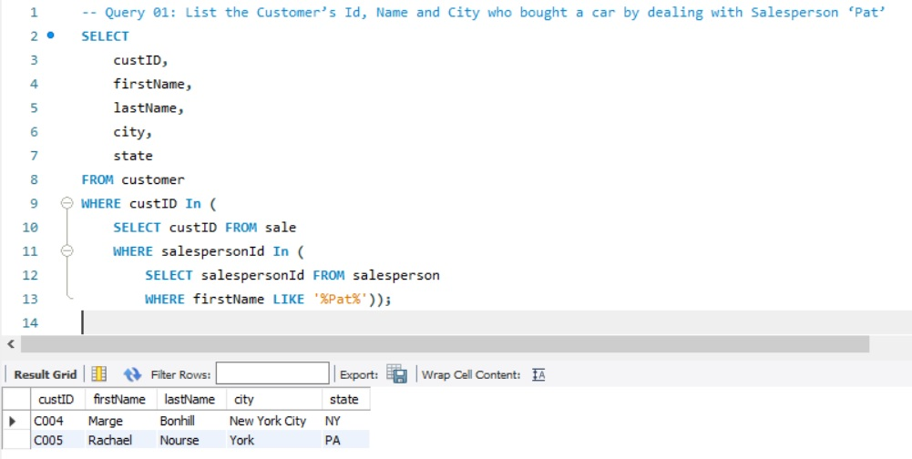

2) List the Warantee details of the new car Land Rover.

**SELECT * FROM warrantee**

**WHERE warType In (**

**SELECT warranteeType FROM sale**

**WHERE newCarVIN In (**

**SELECT VIN FROM newcar**

**WHERE make LIKE ‘%Land Rover%’));**

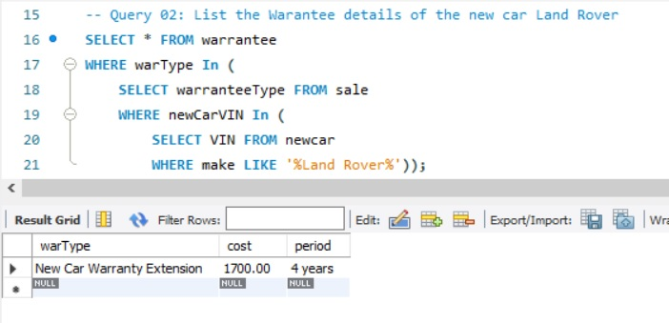

3) List the registration details of the used car Subaru.

**SELECT * FROM registration**

**WHERE regNumber In (**

**SELECT registrationNumber FROM sale**

**WHERE tradeInVIN In (**

**SELECT VIN FROM UsedCar**

**WHERE model LIKE ‘%Subaru%’));**

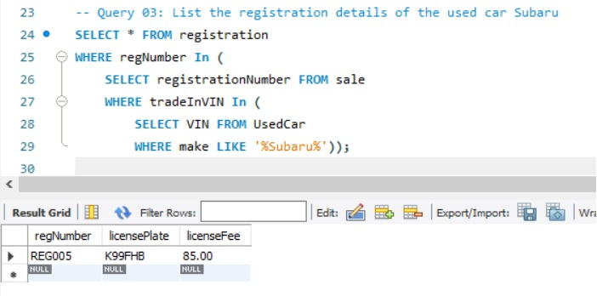

4) List down the VIN and model of the new car whose sale price is 47337.

**SELECT VIN, model FROM newcar**

**WHERE VIN In (**

**SELECT newCarVIN FROM sale**

**WHERE salePrice LIKE ‘%47337%’);**

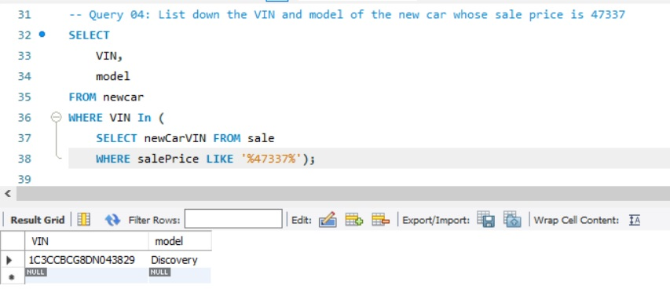

5) List down the Survey details placed by customer Marge.

**SELECT * FROM survey**

**WHERE invoiceNumber In (**

**SELECT invoiceNumber FROM sale**

**WHERE custId In (**

**SELECT custId FROM customer**

**WHERE firstName LIKE ‘%Marge%’));**

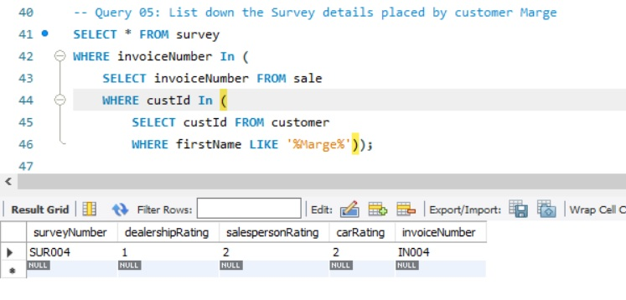

Step 5.6 - Write and execute SQL statements to create at least one trigger.

**CREATE TRIGGER formatting_values**

**BEFORE INSERT ON customer**

**FOR EACH ROW**

**SET**

**NEW.firstName = CONCAT(UPPER(LEFT(new.firstName, 1)), SUBSTRING(new.firstName, 2)),**

**NEW.lastName = CONCAT(UPPER(LEFT(new.lastName, 1)), SUBSTRING(new.lastName, 2)),**

**NEW.custId = CONCAT(UPPER(LEFT(new.custId, 1)), SUBSTRING(new.custId, 2)),**

**NEW.city = CONCAT(UPPER(LEFT(new.city, 1)), SUBSTRING(new.city, 2)),**

**NEW.state = UPPER(NEW.state);**

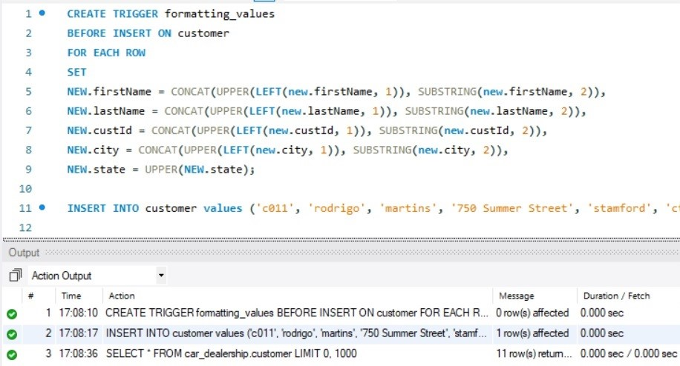

Step 5.7 - Write and execute SQL statements to demonstrate that the trigger is working as expected.

1. **Checking Trigger formatting_values:**

**INSERT INTO customer values ('c011', 'rodrigo', 'martins', '750 Summer Street', 'stamford', 'ct', null, null, null, null, null, null);**

